**By Ritesh Kumar**

**LAB – 5**

**SPRING MVC**

(Documents)

**Home Page**

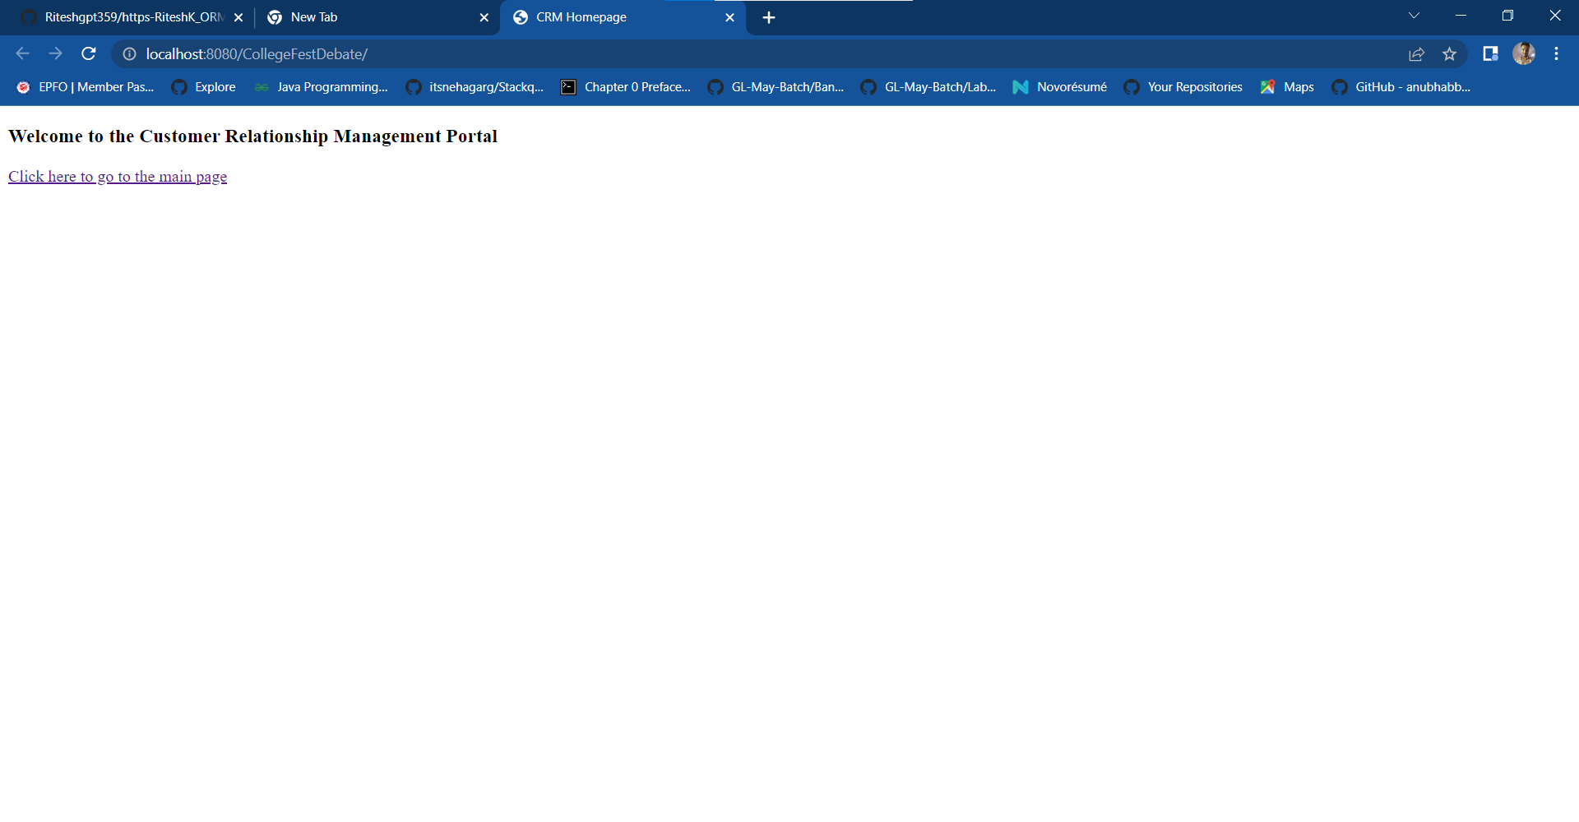

**Student Directory**

**Add Student**

**1.**

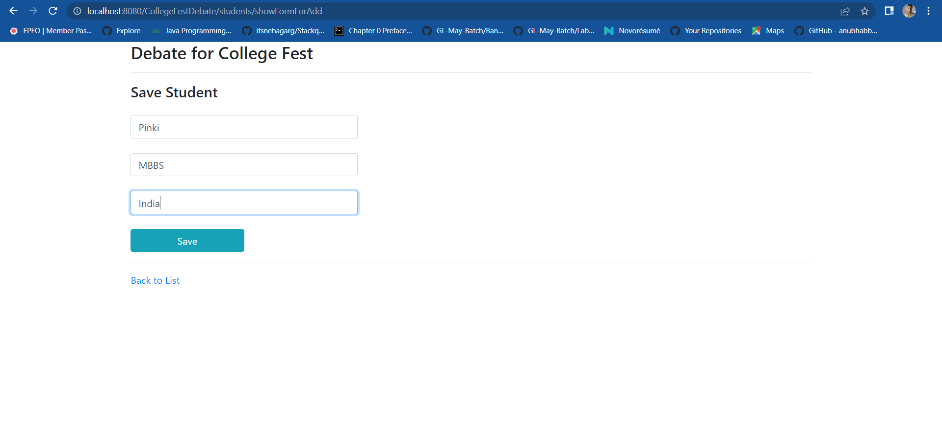

**2.**

**Update Student**

**1.**

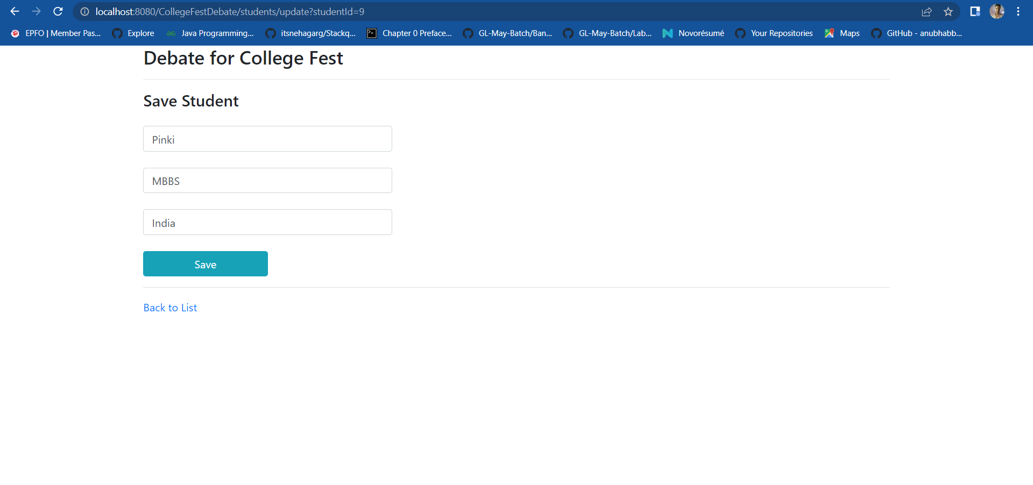

**2.**

**Delete Student**

**1.**

**2.**

